NeuroXAI: A Dual-Stream Explainable AI Framework Integrating MRI and Clinical Biomarkers for Cognitive Impairment Screening
E.Sophiya  Computer Science and Engineering  Vel Tech Rangarajan Dr. Sagunthala R&D  Institute of Science and Technology  Chennai, India  drsophiyae@veltech.edu.in | S.GangaTaruni  Computer Science and Engineering  Vel Tech Rangarajan Dr. Sagunthala R&D  Institute of Science and Technology  Chennai, India  vtu28781@veltech.edu.in | A.yerri Swamy  Computer Science and Engineering  Vel Tech Rangarajan Dr. Sagunthala R&D  Institute of Science and Technology  Chennai, India  vtu29939@veltech.edu.in

Abstract—NeuroXAI is a dual-stream explainable AI framework that combines brain MRI images with clinical biomarkers to screen for cognitive impairment. The image branch uses a pre-trained ResNet-18 network to learn structural patterns from the MRI, while the clinical branch is a small network that encodes age, gender, education, MMSE, CDR Sum-of-Boxes, and FAQ scores. The two branches are fused into a single representation, which is then classified as Normal or Impaired. The MRI and clinical records were matched using subject identifiers from the Alzheimer's Disease Neuroimaging Initiative (ADNI), and the cases with Mild Cognitive Impairment and Alzheimer's disease were grouped together under the Impaired label so that the task becomes a binary screening problem. The model achieved a strong classification accuracy and weighted F1-score on the held-out testing split, with the best checkpoint selected using this evaluation. Beyond the prediction itself, NeuroXAI provides two forms of explanation: Grad-CAM highlights the regions of the MRI that most influenced the decision, while a mean-replacement technique shows how each clinical value individually affects the predicted probability. Both explanations, along with the prediction, are presented together through an interactive web dashboard, giving users a clear view of what the model predicted and why. This paper describes how the dataset was constructed, how the dual-branch model was designed and trained, and how its predictions can be interpreted through the accompanying explanation modules.
Index Terms—Cognitive Impairment, XAI, Multimodal Fusion, ResNet-18, Grad-CAM, Clinical Feature Attribution, ADNI, Magnetic Resonance Imaging.
I. INTRODUCTION
NeuroXAI is designed to take a brain MRI image and a short clinical record and combine them to screen for cognitive impairment. The MRI will give information about the structure of the brain, while the clinical scores give information about a person’s cognition and day to day functionality [6], [7]. The aim of this project is to combine the two pieces of information and provide explanation on how the model arrived at its prediction, rather than relying on a single unexplained label. The task is to separate the cognitively normal subjects from those with MCI or AD using matched ADNI data [4]. The overall design is intentionally kept simple: each branch uses a standard, well

understood encoder, and the two sets of learned features are joined through a single fusion layer rather than a complex mathematical formulation, so that the pipeline remains easy to follow from input to prediction.
A class label only provides limited information on how the model made its decision. Therefore, this system provides an explanation on both branches. The Grad-CAM provides an explanation of areas of interest within the image based on the chosen class score. The clinical explanation replaces one clinical value at a time to see how the output is affected. While this provides insight into the model, it is not a medical diagnosis or proof that this input caused this issue. This two-sided approach means a reviewer can check whether the areas highlighted in the image and the clinical values driving the score line up with what would normally be expected, rather than trusting the predicted label on its own.
This project outlines the steps taken to develop the model from the downloaded data, starting from the raw scans and clinical records and ending with a trained, explainable classifier. The MRI and clinical data was matched, cleaned, and prepared before training. The data was then trained on using a dual branch model whose basic design is described later in this paper without relying on heavy mathematical notation. This experiment was explained using training curves and classification scores. An explanation was also provided using a dashboard. Finally, the model provides a binary output of Normal or Impaired. Within this paper, "Impaired" refers to MCI and AD.
Two branches were used as the MRI and clinical data could not be read in the same way. The image network will learn patterns from the pixel data. The clinical network will read the short list of values. Both branches will first encode the input into learned features, turning the raw image and the raw clinical numbers into two short lists of numbers that the rest of the model can work with. Then the features are combined so the final part of the model can use both inputs to make a decision. This is known as multimodal fusion. No complex equations are needed to describe this step, it is simply a case of joining the two feature lists together before the final decision layer.
An important part of this project was ensuring the inputs were linked to the correct subject. The model should not be given one person's MRI and another's clinical data. Subject IDs were used to match the downloaded files. This also linked the example with its diagnosis. Therefore, the matching was part of the model pipeline.
II. RELATED WORK
This section surveys the main techniques that this project builds on, covering the image model, the explanation methods, and the clinical scores, before the following section describes how they are combined into a single system. This system uses many well-known techniques. The ResNet was developed to use residual learning in image recognition [1]. The ResNet-18 was used in this project as the image input was pre-trained on ImageNet. Grad-CAM was used to provide a visual explanation for a convolutional network [2]. SHAP is related work that assigns values to the input features [3], however within this project, a simple replacement technique was used instead of SHAP to explain the clinical data. The MMSE, CDR, and FAQ scores provide the clinical assessments [6]-[8]. The data was sourced from ADNI [4]. Other related work includes multimodal and longitudinal data [9], XAI for brain imaging [10], methods for detecting AD [11], and language models for ADNI [12]. Another review provides information on MRI based models and multimodal methods [13]. These studies provide context on how to combine image features, clinical data, and explanations.
The ResNet-18 provides the image encoding, while the small clinical network provides a second encoder. The Grad-CAM and clinical replacement provide explanations after predictions. However, they do not create any new classes for diagnosis. The clinical explanation is not using SHAP within this paper. This is due to the calculations being different. The question is asking, if we replace one clinical value with its mean from training, what happens to our chosen probability? This only applies to that specific input and reference value and does not claim to split the prediction into exact SHAP values.
III. MATERIALS AND METHODS
A. Dataset
The MRI and clinical data were obtained from ADNI with a signed data usage agreement. The clinical data was obtained from the ADSL table. The T1 weighted MPRAGE scans were downloaded separately. When searching for the images, only Screening and Baseline visits were selected. Only those with MPRAGE noted under MRI were selected. The images were matched to the clinical data using subject IDs. Only subjects with valid scans and diagnosis were used. This provided 403 examples, with 115 CN, 198 MCI, and 90 Dementia/AD examples, as shown in Figure 1(a).
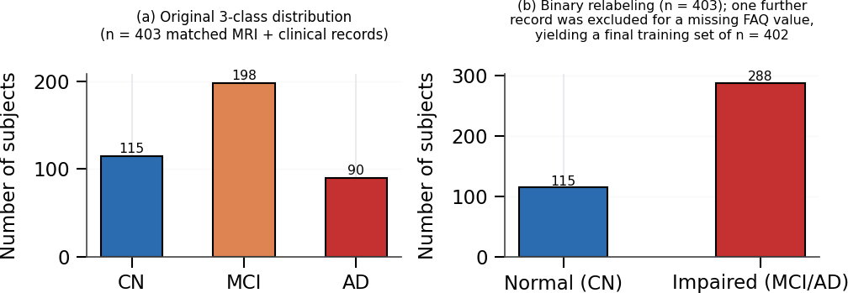
Fig. 1. Distribution of diagnosis classes within the matched ADNI cohort. (a) The original 3 classes, (b) The binary classes used for training the model. One example was removed within quality filtering due to missing FAQ values.
The final task in this project was binary. The CN examples were labelled as Normal (label 0), while the MCI and AD examples were labelled Impaired (label 1). Before checking for missing values there were 115 Normal examples and 288 Impaired examples, as shown in Figure 1(b). Initial experiments were undertaken with the 3 classes, however these had varying validation results. Therefore, the final experiment was completed using the binary task. One example was removed due to missing FAQ score, providing 402 examples. All classification results refer to the 2 class task.
A full example requires an image, chosen clinical values, and label. If there was not a matched image, it would not be used in the same way. Similarly, if there was not a valid scan for the clinical data, both inputs would not be provided. Therefore, the matched cohort refers to those subjects where the data could be matched. Initially there were 403 examples and finally 402.
The labels have been grouped however this doesn't affect the original diagnosis from ADNI. Normal will still be based on the CN examples. The MCI and AD examples do not change their diagnosis, however they do both have the same output label for this experiment. The model has been trained on a 2 class task, however originally there were 3 groups. Both views are shown in Figure 1.
B. Clinical Feature Selection
The clinical branch uses 6 values. These are age, gender, years of education, MMSE [6], CDR Sum-of-Boxes [7], and total FAQ [8]. These are also used within the dashboard. Originally it was planned to use nWBV and eTIV. However, these values were not used. The UCSFFSX51 table had regional measurements and there was no whole brain value provided. Therefore, no value was created.
The order of the 6 inputs is important. As each value has learned weights, the position of the value within the clinical vector will matter. For example, if the MMSE value is inputted, then during prediction, the value must be in the same position as during training. The dashboard and training data will have the same 6 fields.

The standardisation method scales the values to a common numerical scale. This is done by subtracting the training mean for each feature from the observed value and dividing by the training standard deviation. The training statistics are used during evaluation. Therefore, the values are not calculated again. Zero represents the training mean.
C. Image Preprocessing
The DICOM with the most slices per subject was selected. The middle slice was converted to greyscale and duplicated to 3 channels. The image was then scaled to 224x224 and standardised using ImageNet. This provided an image suitable for the pre-trained ResNet-18. Each subject only provides one 2D image.
Converting the greyscale image to 3 channels does not provide any new medical information. It just changes the format of the input. The 3 channels will have the same greyscale information. This provides the selected slice with the correct format for the pre-trained image network. Scaling ensures all images are the same width and height. This allows the images to be processed in batches.
The image shown to the model is the selected 2D slice. The heatmap will also be applied to this slice. Therefore, the heatmap should not be seen as an explanation of the full MRI.
D. Model Architecture
The two branches are combined as shown in Figure 2. The image branch is a pre-trained ResNet-18 network. The original output layer has been replaced with a linear layer, batch norm, ReLU, and dropout. This provides 512 image features. The clinical branch provides 64 clinical features by using 2 layers with 64 units. The outputs are combined to create a vector with 576 values. This then goes through a fusion block with a linear layer, batch norm, ReLU, and dropout (0.3). Finally, 2 class scores are produced. Each stage of this pipeline has a clear job: the ResNet-18 backbone turns the raw MRI slice into a compact description of the brain’s structure, the small clinical encoder turns the six raw clinical numbers into a learned representation of a person’s cognitive and functional status, and the fusion block is the single point where these two descriptions are brought together so the model can weigh both sources of evidence before producing its final Normal or Impaired score. Keeping the clinical encoder separate from the image encoder, and only joining them at the fusion stage, means each branch can specialise in the type of input it receives before any information is shared.
The feature sizes make this easy to understand. The image branch provides 512 values. The clinical branch provides 64 values. This means that the combined vector is 576 values. Then the fusion layer reduces this to 128 values. The two branches have been combined after learning features. Reducing the 576 value vector down to 128 values before the final classifier forces the model to keep only the most useful combined information from both branches, rather than passing every raw feature through unchanged.
The features are numerical values created by the encoders. Therefore, the image branch will provide 512 features while the clinical branch provides 6 values. The clinical branch will also turn the 6 raw values into 64 learned features. The final classifier is using the learned features.
The final scores use the same labels as the prepared dataset. There will be one score for Normal and one for Impaired. The dashboard will show the selected class with a probability from the model. This is a measure of how the model has performed with the given inputs. It is not measuring how far along the disease progression they are.
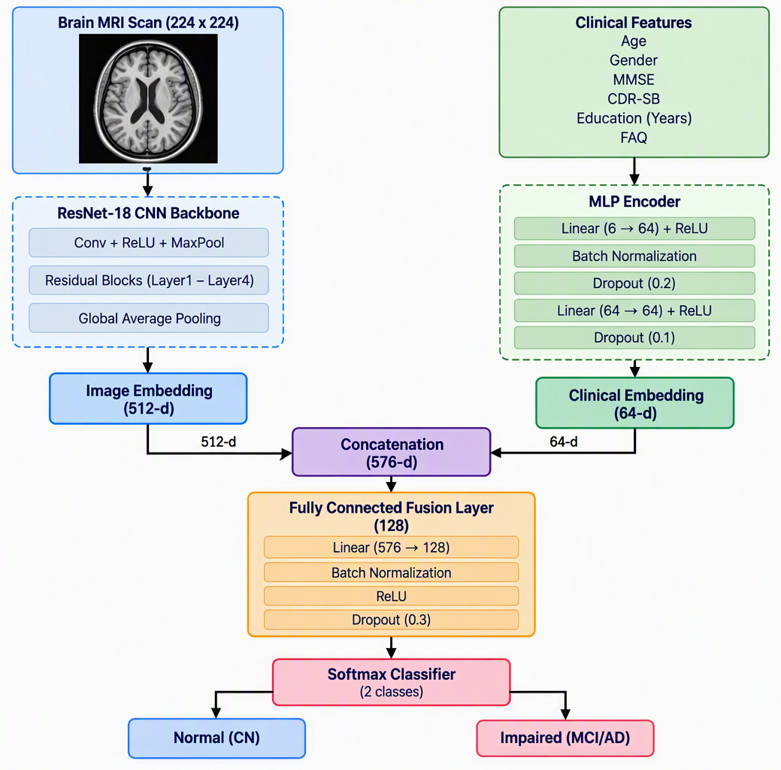
Fig. 2. Dual stream multimodal fusion with ResNet-18 image encoder and MLP clinical encoder.
E. Training Setup
The 402 examples were split into training and testing data using an 80/20 stratified split. The clinical data was standardised using only the training mean and standard deviation. The images were altered using random horizontal flips and rotations of up to +/-10 degrees. The model was created using PyTorch [5]. The training parameters are shown in Table I.
The data was split using stratified sampling. This means that the split was done using the person represented by the example. This ensures that the labels are considered when creating the training and testing groups. The model was trained using the training group. The testing group was used to track the performance of the model during the run. This split was used for all 15 epochs.
The image augmentation provides variation to the training images. However, this does not provide any new clinical examples or people. There are still 402 examples within the
cohort. Details on the optimiser, learning rate, batch size, and network sizes are shown in Table I. These should be considered with the data preparation.
TABLE I HYPERPARAMETERS
Hyperparameter | Value
Image branch | ResNet-18 (Pretrained on ImageNet)
Image Embedding Size | 512
Clinical Embedding Size | 64
Hidden Fusion Size | 128
Image input size | 224x224x3
Clinical Inputs | 6 (Age, Gender, MMSE, CDR-SB, Educ., FAQ)
Batch Size | 16 (drop_last=True)
Optimiser | Adam (weight decay=1e-4)
Learning Rate | 0.001
Epochs | 15
Train/Test Split | 80%/20% (Stratified on subject)
F. Explanation Modules
The image explanation uses Grad-CAM [2]. The gradients from the selected class score are taken from the last convolutional layer in the ResNet-18. This creates a heatmap. The clinical explanation replaces one standardised clinical value with zero. This represents the mean value from training. The image and remaining 5 values remain the same. The difference in the selected class probability is recorded. This is repeated for all 6 clinical values. A positive value means that replacing the value has reduced the probability of the selected class. A negative value means that replacing the value has increased the probability. This is not calculating SHAP values. Both explanations are provided alongside the prediction.
The clinical example starts with the original probability. One feature is replaced with the reference value and the probability is calculated again. This difference in probabilities is displayed. This is repeated for all 6 features. The MRI will remain unchanged.
The reference value is just for comparison. It does not mean that the training mean is the correct value for everyone. For example, if we replace a score with its mean, we are seeing how the model output changes compared to a reference value. We are not simulating any treatment. We are just measuring how the model performs with one input changed.
The size and sign of this value tell a simple story about one feature for one subject. A value close to zero shows that swapping in the reference value barely moved the predicted probability, so that feature was not driving the decision in this case. A large positive value shows that the actual input pushed the probability higher than the reference value would have, while a negative value shows the reverse, that using the reference value would have raised the probability instead. These attributions stay local to the current input: because the remaining five values and the model’s learned behaviour differ from subject to subject, the same feature can produce a different attribution for a different person.
IV. EXPERIMENTAL RESULTS
A. Classification Results
The model was trained for 15 epochs. The highest accuracy was achieved on the 20% testing data, with 93.83%. This was first achieved at epoch 10. This was also achieved at epoch 11 and 14. The weighted F1-score was 0.9387, as shown in Table II. The model was tested on the testing split to find the best model checkpoint.
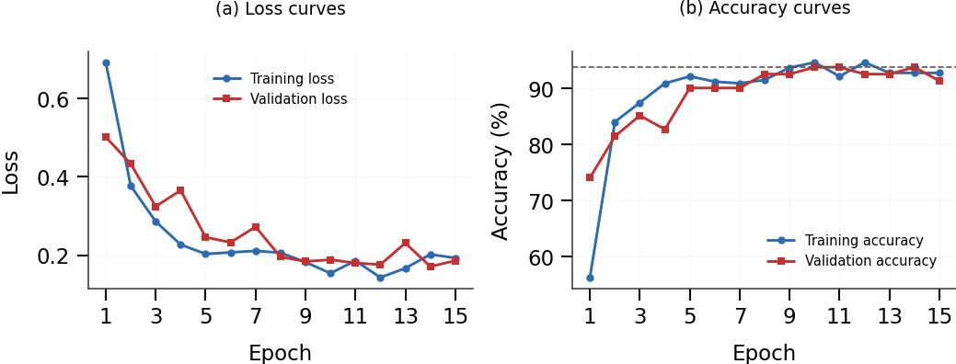
Fig. 3. Training and testing curves. (a) Loss values and (b) Accuracy values. The testing curves are labelled as validation. The highest accuracy achieved was 93.83%.
B. Training Curve
Figure 3 provides an overview of the training. The training accuracy increased from 56.3% to a maximum of 94.7%. The testing accuracy increased from 74.1% to 93.83%. The lowest loss value achieved was 0.1715 near epoch 14. This provides an overview of how the model changed throughout training. The curves do not indicate how the model will perform on a new independent group of subjects.
The accuracy shows how often the binary label was correctly predicted. The weighted F1-score combines the F1-scores of each class using the number of examples within each class as weights. This is the same testing run as the accuracy. The value of 0.939 is due to rounding. The exact value has been provided in the table to avoid confusion.
The classes are not balanced before the missing values were removed. This is why the label counts have been provided alongside the accuracy. A single overall score does not provide information on all mistakes. The weighted F1-score provides further information. If the precision, recall, and confusion matrix were available for each class, further information could be provided. No extra values have been added for each class.
The highest accuracy was achieved multiple times. This was due to one training run. This shows that the highest accuracy recorded was achieved at multiple checkpoints. The curves provide an overview of how the model trained, while the table provides the summary values. No external independent testing has been added.
TABLE II BEST EPOCH CLASSIFICATION RESULTS (BINARY: NORMAL vs. IMPAIRED)
Metric | Value
Best Epoch | 10 (Matched at 11, 14)
Test Accuracy | 93.83%
Weighted F1 Score | 0.9387
Final Cohort Size (n) | 402
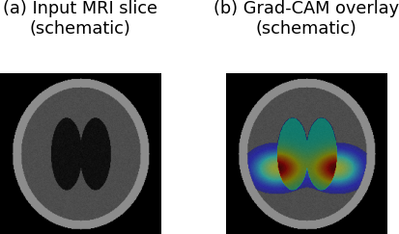
Fig. 4. Diagram showing how a heatmap can be overlaid onto an MRI slice using the Grad-CAM technique. This is not a measured heatmap from a patient.
C. Qualitative Explanation Results
Figure 4 provides an overview of how the heatmap can be overlaid onto an MRI slice. This is a diagram and not a measured heatmap from a patient. This cannot be used as evidence that the model found a certain area of the brain.
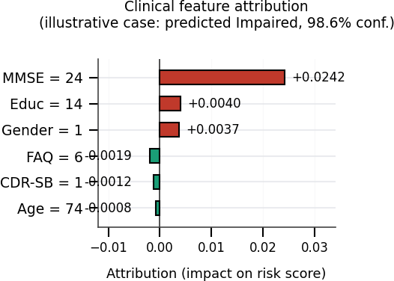
Fig. 5. Example of features attribution for clinical information for an Impaired prediction. This shows the effect of substituting each feature with the reference value.
In Fig. 5 we get an example of the clinical explanation for the output of Impaired, which is 98.6% in this case. We observe that MMSE has the highest positive value, which is +0.0242. Then Education and Sex have smaller positive values. FAQ, CDR Sum-of-Boxes and Age have small negative values. This is

dependent on the input being substituted in this example. This is not a generalised feature ranking for the six inputs and the model probability given is not a quantified or calibrated risk.
The dashboard provides a simple way to view all the inputs and outputs. Here the MRI input represents the image branch and the six clinical inputs represent the clinical branch. We observe the predicted class, image heatmap and clinical attribution. There is no new definition of labels or clinical information being used.
The workflow from the prepared example to the displayed result uses the same design as the training process. The image is formatted in an appropriate way for the image encoder. The clinical inputs are formatted using the feature definitions and scaling described above. The encoders will generate their features, the fusion layers generate class scores and the explanation modules will examine the selected output. This gives a better understanding of the relationship between the displayed result and the methods described in the paper.
The purpose of each figure can be seen. In the class distribution plot we observe what records were used to create the dataset. The architecture plot shows how the two branches are joined. The training plots show the training process over 15 epochs. The schematic heatmap and example feature attribution plot give an explanation of how the output is displayed. This ensures that the example output isn’t interpreted as quantified patient information.
V. DISCUSSION
The system has been created to combine both the MRI and clinical information. It has an accuracy of 93.83% for the Normal/Impaired classification task for this ADNI dataset. This doesn’t indicate how well the model can distinguish between MCI and AD. The image branch only uses a single 2D slice and the experiment only used a single split at the subject level. As the evaluation set was used to select the best checkpoint, an additional test set would be required to evaluate the selected model independently.
The dashboard shows how the prediction can be analysed using two methods. The Grad-CAM shows how the image is influencing the prediction and the clinical method shows how the prediction changes if one value is substituted. This doesn’t indicate any clinical validity of the model. The schematic and example plots show how the explanations are presented. This shouldn’t be interpreted as quantified patient level information. To compare this accuracy to another study, it would be important to look at the labels, dataset and evaluation method. The working dashboard brings these pieces together in one screen, as shown in Figure 6: the patient’s MRI and clinical inputs are entered on the left, and the predicted class, model confidence, Grad-CAM heatmap, and clinical feature attribution are displayed on the right so the prediction and its explanation can be reviewed side by side.
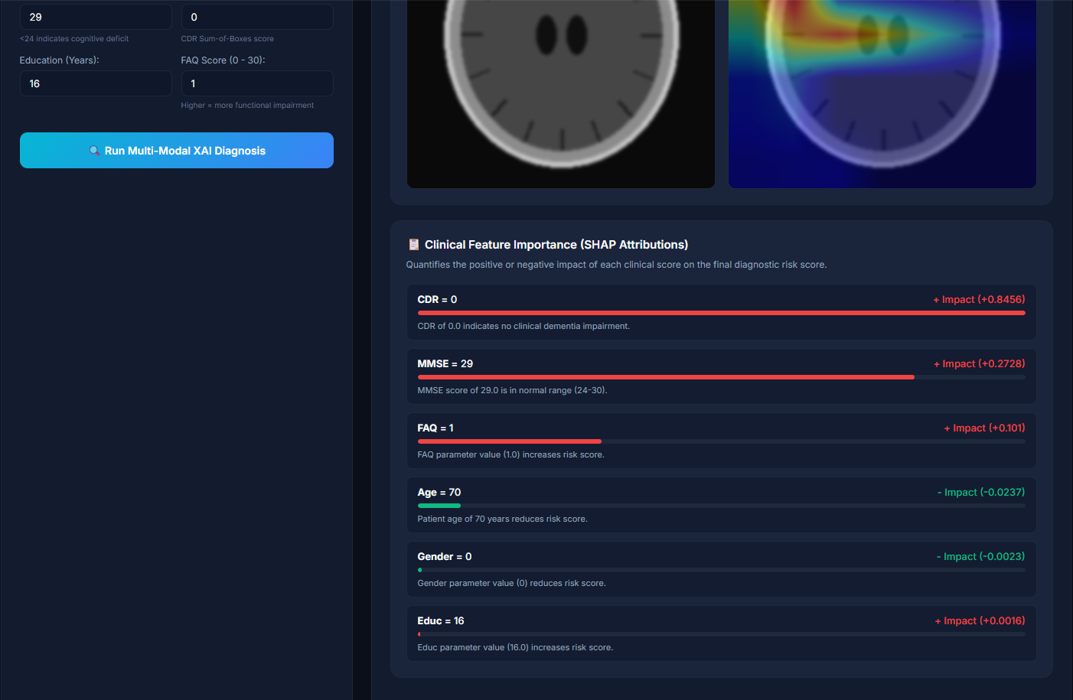
Fig. 6. The NeuroXAI web dashboard, showing patient inputs, the automated diagnostic prediction, the Grad-CAM heatmap, and the clinical feature attribution together on one screen.
This result should be interpreted along with the cohort, label grouping and splitting. If any of these were changed it would constitute a different experiment. For example if the labels were separated into CN, MCI and AD there would be three labels within the output, so the evaluation would need to be
done again. The accuracy given cannot be applied to the future three-class model.
It would be a useful next step to train an image only model and a clinical only model using the same split. This could help demonstrate how much each data type contributes to the combined model. An increased independent cohort would also allow the selected checkpoint to be evaluated without using the same data.
A key factor in reproducibility is having clear rules about how the data was prepared. Selecting specific visits, matching subjects, removing missing data, grouping labels, image sizing, clinical scaling and training settings can all affect what the results mean. All of these decisions are outlined in the tables and method. If future experiments have a different cohort or rules around selecting slices, this would constitute a new experiment.
VI. CONCLUSION AND FUTURE WORK
NeuroXAI has been created to classify cognitive impairments using a single slice of MRI and six clinical values. The data from ADNI was matched and a dataset containing 402 subjects was created. A two branch model was trained and the output linked to explanations using a web dashboard. The best checkpoint had an accuracy of 93.83% with a weighted F1 score of 0.9387 on the evaluation set and checkpoint selection set. This system can currently classify Normal/Impaired but future work can be done to analyse the separate labels of CN/MCI/AD. More work can also be done to use full MRI volumes, subject level cross validation and an independent final test set. Comparing the model with a clinical only and image only model will also help quantify how much each branch contributes.
ACKNOWLEDGMENT
The MRI scans and clinical data were taken from the Alzheimer’s Disease Neuroimaging Initiative (ADNI) database. The dataset was prepared, model designed, trained, evaluated and dashboard implemented as part of this project.
REFERENCES
[1] K. He, X. Zhang, S. Ren, and J. Sun. Deep residual learning for image recognition. In Proc. IEEE Conf. Computer Vision and Pattern Recognition (CVPR), pages 770–778, 2016.
[2] R. R. Selvaraju, M. Cogswell, A. Das, R. Vedantam, D. Parikh, and D. Batra. Grad-CAM: Visual explanations from deep networks via gradient-based localization. In Proc. IEEE Int. Conf. Computer Vision (ICCV), pages 618–626, 2017.
[3] S. M. Lundberg and S.-I. Lee. A unified approach to interpreting model predictions. In Advances in Neural Information Processing Systems (NeurIPS), volume 30, 2017.
[4] R. C. Petersen et al. Alzheimer’s Disease Neuroimaging Initiative (ADNI): Clinical characterization. Neurology, 74 (3):201–209, 2010.
[5] A. Paszke et al. “PyTorch: An imperative style, high-performance deep learning library,”. In Advances in Neural Information Processing Systems (NeurIPS), volume 32, 2019.
[6] M. F. Folstein, S. E. Folstein, and P. R. McHugh. ‘Mini-mental state’: A practical method for grading the cognitive state of patients for the clinician. J. Psychiatric Research, 12 (3):189–198, 1975.

[7] J. C. Morris. The Clinical Dementia Rating (CDR): Current version and scoring rules. Neurology, 43 (11):2412–2414, 1993.
[8] R. I. Pfeffer, T. T. Kurosaki, C. H. Harrah, J. M. Chance, and S. Filos. Measurement of functional activities in older adults in the community. J. Gerontology, 37 (3):323–329, 1982.
[9] S. Muksimova, S. Umirzakova, J. Baltayev, and Y. I. Cho. Multi-modal fusion and longitudinal analysis for Alzheimer’s disease classification using deep learning. Diagnostics, 15 (6):717, 2025.
[10] M. T. Khosroshahi et al. Explainable artificial intelligence in neuroimaging of Alzheimer’s disease. Diagnostics, 15 (5):612, 2025.
[11] S. Mohsen. Alzheimer’s disease detection using deep learning and machine learning: A review. Artificial Intelligence Review, 58:262, 2025.
[12] H. Almalki, A. O. Khadidos, and N. Alhebaishi. Enhancing Alzheimer’s detection: Leveraging ADNI data and large language models for high-accuracy diagnosis. Int. J. Adv. Comput. Sci. Appl., 15 (11), 2024.
[13] R. D. Resen, L. S. Alzubaidi, H. A. Alwzwazy, and M. I. Capel. Review of deep learning models for Alzheimer’s disease detection: MRI-centric approaches and multimodal extensions. Frontiers in Artificial Intelligence, 9, 2026.

